8MP 5MP 4MP 3MP Mini Passive Single HD Video Balun Terminal
Model:STK201P-HD-A1
> No power required, simplified project wiring
> Compatible with HDCVI/ HDTVI/ AHD
> Transmission distance (over Cat 5E/6):
HDCVI 720P: 400M / 1080P: 250M; 4MP:200M ; 8MP:180M(Max)
HDTVI 720P/1080P: 250M; 5MP:200M ;8MP:180M(Max)
AHD 720P: 350M / 1080P:200M; 5MP:200M; 8MP:180M(Max)
> Plug and play, real-time transmit CCTV HD video signal, video is high quality and stable
> Anti-interference, super lighting protection, ESD
> ABS outer shell, convenient to use in intensive project
> Push-terminal,mini size, easier for installation
Description of this 8MP 5MP 4MP 3MP mini Passive single HD video balun Terminal

STK201P-HD-A1 video balun is a passive 1 channel device that allows the transmission of real-time CCTV HDCVI,HDTVI,AHD and CVBS analog video signal via unshielded Twisted Paired (UTP) cable.
The unparralled interference rejection and low emissions of the STK201P-HD-A1 allow video signals to coexist in the same wire bundle as datacom,telephone,or damaging votage spikes.
Mini design,strong enviroment PCB board,copper core,super lighting protection, ESD builted make you better and safety video balun.
Widely used in security, teaching industry and other complex system environment.

Specification of this 8MP 5MP 4MP 3MP mini Passive single HD video balun Terminal
Model | STK201P-HD-A1
Properties
Transmission Signal | 1 channel
Transmission Distance (Max) | HDCVI 720P:400M / 1080P:250M /4MP:200M / 4K 8MP:180M (Max)
 | HDTVI 720P/1080P:250M / 5MP:200M / 4K 8MP:180M(Max)
 | AHD 720P:350M / 1080P:200M / 5MP:200M / 4K 8MP:180M(Max)
Category Type | UTP CAT 5E/6 (R＜10Ω/100M)
Video Transmission Properties And Port
Coaxial Video Connector | BNC-M
Twisted-pair Video Connector | Push-terminal
Compatible Format | HDCVI, HDTVI, AHD, CVBS
Resolution | 720P/1080P/4MP/5MP/8MP 4K
Anti-interference | ＞60db
Protection
ESD | 1a contact discharge electricity level 3
 | 1b air discharge electricity level 3
 | Per:IEC61000-4-2
Coaxial Cable Connector | 2KV(common-code) Per:IEC61000-4-5
UTP Cable Connector | 2KV(different-code),4KV(common-code),Per:IEC61000-4-5
Impedance
BNC Male | 75 ohms
UTP Cable | 100 ohms
Physical Properties
Shell | ABS
Color | Black
N.W. | 23G
Stability
MTBF | ＞10000H
Environmental
Operating Temperature | -10~55℃
Storage Temperature | -20~70℃
Humidity | 0~95%(non-condensing)

Application of this 8MP 5MP 4MP 3MP mini Passive single HD video balun Terminal
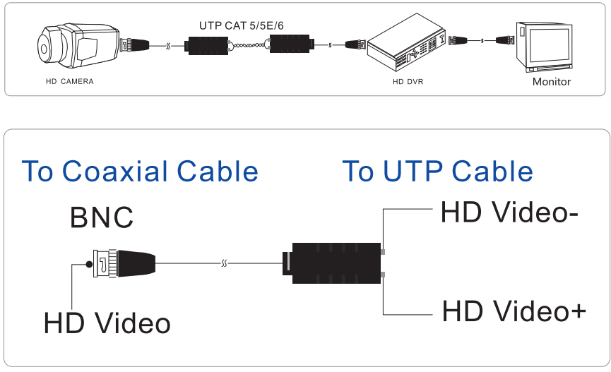

Pictures of this 8MP 5MP 4MP 3MP mini Passive single HD video balun Terminal

