**Economical Passive HD Video Transceiver Mini Design 4K 5MP**

Model:STK201P-HD-A2

>High quality terminal

>1 channel HD Balun for TVI/CVI/AHD/CVBS signal

>No power required, simplified project wiring

>Transmission distance (over Cat 5E/6):

>Plug and play, real-time transmit CCTV HD video signal,

>Anti-interference, super lighting protection, ESD

>Easy to use in intensive project

Description of this Economical Passive HD Video Transceiver mini design 4K 5MP

Model:STK201P-HD-A2  
>CCTV Passive Video Balun:High quality terminal  
>Mini Design Video Balun Transceiver :No power required, simplified project wiring  
>Transmission distance (over Cat 5E/6):  
>4K 5MP CCTV Video Transceiver :Real-time transmit CCTV HD video signal,  
>Anti-interference, super lighting protection, ESD  
>Mini Economical HD Balun Transceiver :Easy to use in intensive project

Specification of this Economical Passive HD Video Transceiver mini design 4K 5MP

|  |  |
| --- | --- |
|  | |
|  | |
|  | |
|  | |
| Model | STK201P-HD-A2 |
| Properties | |
| Transmission Signal | one channel |
| Transmission Distance (Max) | HDCVI 720P:400M / 1080P:250M /4MP:200M / 4K 8MP:180M (Max) |
| HDTVI 720P/1080P:250M / 5MP:200M / 4K 8MP:180M(Max) |
| AHD 720P:350M / 1080P:200M / 5MP:200M / 4K 8MP:180M(Max) |
| Category Type | UTP CAT 5E/6 (R＜10Ω/100M) |
| Video Transmission Properties And Port | |
| Coaxial Video Connector | BNC-Male |
| Twisted-pair Video Connector | Push-terminal |
| Compatible Format | HDCVI, HDTVI, AHD, CVBS |
| Resolution | 720P/1080P/4MP/5MP/8MP 4K |
| Anti-interference | ＞60db |
| Protection | |
| ESD | 1a contact discharge electricity level 3 |
| 1b air discharge electricity level 3 |
| Per:IEC61000-4-2 |
| Coaxial Cable Connector | 2KV(common-code) Per:IEC61000-4-5 |
| UTP Cable Connector | 2KV(different-code),4KV(common-code),Per:IEC61000-4-5 |
| Impedance | |
| BNC Male | 75 ohms |
| UTP Cable | 100 ohms |
| Physical Properties | |
| Shell | ABS |
| Color | Black |
| N.W. | 23G |
| Stability | |
| MTBF | ＞10000H |
| Environmental | |
| Operating Temperature | -10~55℃ |
| Storage Temperature | -20~70℃ |
| Humidity | 0~95%(non-condensing) |

Application of this Economical Passive HD Video Transceiver mini design 4K 5MP

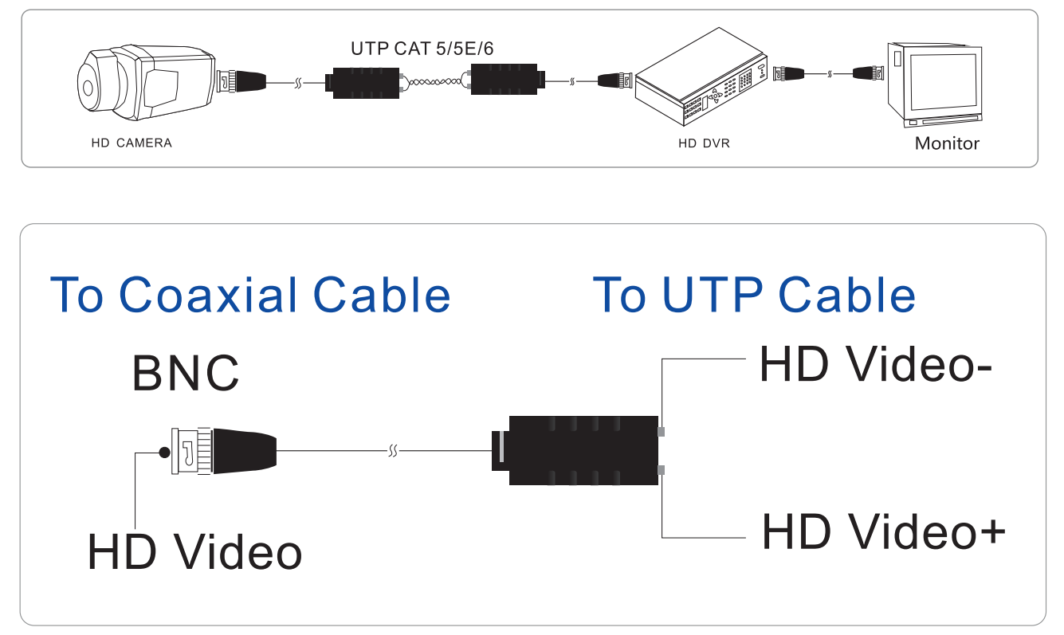

Pictures of this Economical Passive HD Video Transceiver mini design 4K 5MP

