Single Channel Passive HD Balun For TVI CVI AHD CVBS
> Model number: STK201P-HD-B2
> No power required, simplified project wiring
> Compatible with HDCVI/ HDTVI/ AHD
> Plug and play, real-time transmit CCTV HD video signal, video is high quality and stable
> Anti-interference, super lighting protection, ESD
Description of this Single Channel Passive HD Balun For TVI CVI AHD CVBS

STK201P-HD-B2 cctv passive video balun is a passive (non-amplified) device that allows the transmission of real-time CCTV HD video signal via cost-effective Unshielded Twisted Paired (UTP) cable. The TT-201P-HD-B2 CCTV Accessories Video Balun is compatible with all HD-TVI, HD-CVI, AHD and CVBS analog cameras.
Single Channel Hd Video Balun has a mini-coax pigtail lead which allows quick mounting onto fixed cameras, allows in-camera mounting in most dome cameras and allows flexible connection with DVR. Screw-pin terminal block allows easy connection of UTP cable output. Used in pairs, STK201P-HD-B2 Video Balun For TVI CVI AHD CVBS, eliminates costly and bulky coaxial cable.
The superior interference rejection and low emissions of the STK201P-HD-B2 Hd CCTV Video Balun,allow video signals to coexist in the same wire bundle as telephone, datacom, or damaging voltage spikes. CCTV Accessories Single Channel Balun crosstalk and noise immunity ensure quality video signals. Widely used in security, teaching industry and other complex system environment.

Specification of this Single Channel Passive HD Balun For TVI CVI AHD CVBS

Model | STK201P-HD-B2
Properties
Transmission Signal | 1 channel
Transmission Distance (Max) | HDCVI 720P: 400M / 1080P: 250M; 4Mp:200M ;5Mp:200M; 8MP: 180M
 | HDTVI 720P/1080P: 250M; 5Mp:200M ; 8MP: 180M
 | AHD 720P: 350M / 1080P: 200M;5Mp:200M; 8MP: 180M
Category Type | UTP CAT 5E/6 (R＜10Ω/100M)
Video Transmission Properties And Port
Coaxial Video Connector | BNC-M
Twisted-pair Video Connector | Screw terminal
Compatible Format | HDCVI, HDTVI, AHD, CVBS
Resolution | 720P/1080P/4MP/5MP/8MP 4K
Anti-interference | ＞60db
Protection
ESD | 1a contact discharge electricity level 3
 | 1b air discharge electricity level 3
 | Per:IEC61000-4-2
Coaxial Cable Connector | 2KV(common-code) Per:IEC61000-4-5
UTP Cable Connector | 2KV(different-code),4KV(common-code),Per:IEC61000-4-5
Impedance
BNC Male | 75 ohms
UTP Cable | 100 ohms
Physical Properties
Shell | ABS
Color | Black
N.W. | 50G
Stability
MTBF | ＞10000H
Environmental
Operating Temperature | -10~55℃
Storage Temperature | -20~70℃
Humidity | 0~95%(non-condensing)

Application of this Single Channel Passive HD Balun For TVI CVI AHD CVBS

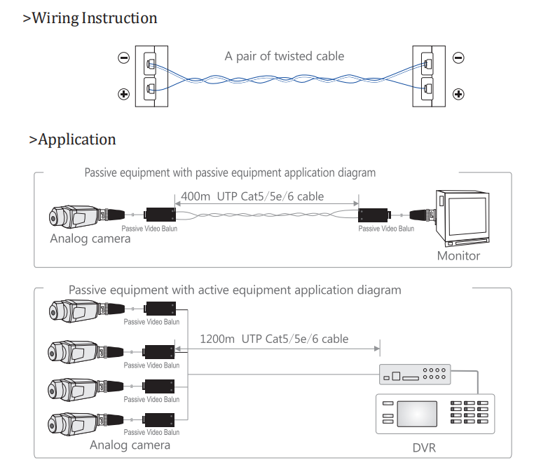

Pictures of this Single Channel Passive HD Balun For TVI CVI AHD CVBS

