HD Video Transceiver Connect UTP CAT5 5E 6
> No power required, simplified project wiring
> Compatible with HDCVI/ HDTVI/ AHD
> Plug and play, real-time transmit CCTV HD video signal, video is high quality and stable
> Anti-interference, super lighting protection, ESD
> ABS outer shell, convenient to use in intensive project
> Push-terminal with pigtail, easier for installation
Description of this HD Video Transceiver Connect UTP CAT5 5E 6
STK201P-HD-D2 video balun is a passive (non-amplified) device that allows the transmission of real-time CCTV HD video signal via cost-effective Unshielded Twisted Paired (UTP) cable. The STK201P-HD-D2 is compatible with all HD-TVI, HD-CVI, AHD and CVBS analog cameras.
Used in pairs, STK201P-HD-D2eliminates costly and bulky coaxial cable. The superior interference rejection and low emissions of the STK201P-HD-D2 allow video signals to coexist in the same wire bundle as telephone, datacom, or damaging voltage spikes. Its crosstalk and noise immunity ensure quality video signals. Widely used in security, teaching industry and other complex system environment.
Specification of this HD Video Transceiver Connect UTP CAT5 5E 6

Model | STK201P-HD-D2
Properties
Transmission Signal | 1 channel
Transmission Distance (Max) | HDCVI 720P: 400M / 1080P: 250M; 4Mp:200M ;5Mp:200M; 8MP: 180M
 | HDTVI 720P/1080P: 250M; 5Mp:200M ; 8MP: 180M
 | AHD 720P: 350M / 1080P: 200M;5Mp:200M; 8MP: 180M
Category Type | UTP CAT 5E/6 (R＜10Ω/100M)
Video Transmission Properties And Port
Coaxial Video Connector | BNC-M
Twisted-pair Video Connector | Press-fitting terminal
Compatible Format | HDCVI, HDTVI, AHD, CVBS
Resolution | 720P/1080P/4MP/5MP/8MP 4K
Anti-interference | ＞60db
Protection
ESD | 1a contact discharge electricity level 3
 | 1b air discharge electricity level 3
 | Per:IEC61000-4-2
Coaxial Cable Connector | 2KV(common-code) Per:IEC61000-4-5
UTP Cable Connector | 2KV(different-code),4KV(common-code),Per:IEC61000-4-5
Impedance
BNC Male | 75 ohms
UTP Cable | 100 ohms
Physical Properties
Shell | ABS
Color | Black
N.W. | 50G
Stability
MTBF | ＞10000H
Environmental
Operating Temperature | -10~55℃
Storage Temperature | -20~70℃
Humidity | 0~95%(non-condensing)

Application of this HD Video Transceiver Connect UTP CAT5 5E 6

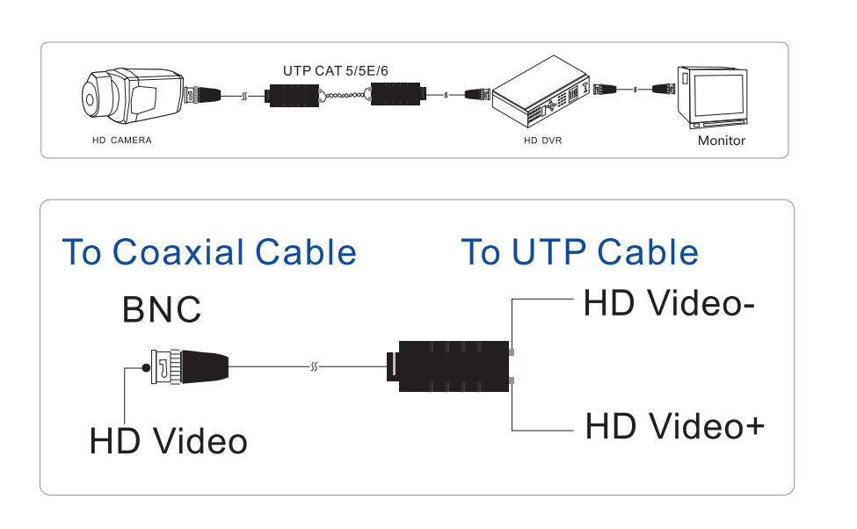
Pictures of this HD Video Transceiver Connect UTP CAT5 5E 6

