4 channels Passive HD UTP Video Transceiver
Model number: STK204P-HD
Color HD video up to 600m with active receiver
Color HD video transmission distance with passive transceiver:
HDCVI 720P: 400M / 1080P: 250M; 4Mp:200M ;5Mp:200M; 8MP: 180M
HDTVI 720P/1080P: 250M; 5Mp:200M ;8MP: 180M
AHD 720P: 350M / 1080P: 200M;5Mp:200M; 8MP: 180M
Built in TVS surge protection,metal shell
Description of this 4 channels Passive HD UTP Video Transceiver

The STK204P-HD video balun hub is a passive (non-amplified) device that allows the transmission of real-time CCTV HD video signal via cost-effective Unshielded Twisted Paired (UTP) cable. Baseband (composite) signals of any type are supported.
STK204P-HD supports pluggable screw terminal or RJ45 connections. Used with single channel HD passive video transmitter, it is capable to receive 4 channel live CCTV HD video signal from camera end via one UTP cable.
The superior interference rejection and low emissions of the STK204P-HD allow video signals to coexist in the same wire bundle as telephone, datacom, or low-voltage power circuit. This allows the use of a shared or existing ccable plant. The TT-204P-HD is built-in surge suppressor to protect video equipment against damaging voltage spikes and provide noise immunity to ensure quality signals without disturbing "hum-bars".
Specification of this 4 channels Passive HD UTP Video Transceiver

Model | STK204P-HD
Properties
Transmission Signal | 4 channel
Transmission Distance (Max) | HDCVI 720P: 400M / 1080P: 250M; 4MP:200M ; 4K/8MP: 180M(Max)
 | HDTVI 720P/1080P: 250M; 5MP:200M ; 4K/8MP: 180M(Max)
 | AHD 720P: 350M / 1080P: 200M; 5MP:200M; 4K/8MP: 180M(Max)
Video Transmission Properties And Port
Video Connector | BNC-F
UTP Cable Connector | 8 pin green terminal block, RJ-45
Compatible Format | HDCVI, HDTVI, AHD, CVBS
Resolution | 720P/1080P/4MP/5MP/8MP 4K
Anti-interference | ＞60db
Protection
ESD | Contact discharge:6000V Air discharge:8000V  Per: IEC61000-4-2
Video Connector Protection | 2KV(common mode) Per: IEC61000-4-5
UTP Cable Connector | 2KV(different-code),4KV(common-code),Per:IEC61000-4-5
Physical Properties
Shell | ABS
Color | Black
N.W. | 558G
Stability
MTBF | ＞10000H
Environmental
Operating Temperature | -10~55℃
Storage Temperature | -20~70℃
Humidity | 0~95%(non-condensing)

Application of this 4 channels Passive HD UTP Video Transceiver
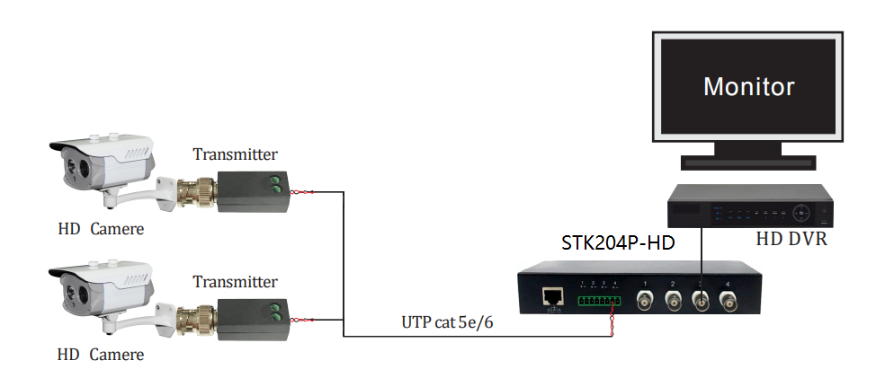
Pictures of this 4 channels Passive HD UTP Video Transceiver

