8 Channels Video Balun Connect UTP Cable Plug and Play
> Model number: STK208P-HD
> Compatible with HDTVI/HDCVI/AHD signal.
> Color HD video up to 500m with active receiver
> Color HD video transmission distance with passive transceiver:
HDCVI 720P: 400M / 1080P: 250M; 4Mp:200M ; 5Mp:200M ; 8MP: 180M
HDTVI 720P/1080P: 250M; 5Mp:200M ;8MP: 180M
AHD 720P: 350M / 1080P: 200M;5Mp:200M; 8MP: 180M
> Super surge protection & interference rejection.
Description of this 8 channels Video Balun connect UTP cable Plug and play

The STK208P-HD video balun hub is a passive (non-amplified) device that allows the transmission of real-time CCTV HD video signal via cost-effective Unshielded Twisted Paired (UTP) cable. Built in TVS for surge protection, very well protected the equipment to work properly, not affected by lightning. Supports pluggable screw terminal or RJ45
connections. Used with single channel HD passive video transmitter, it is capable to receive 8 channel live CCTV HD video signal from camera end via 2 UTP cable.

Specification of this 8 channels Video Balun connect UTP cable Plug and play

Model | STK208P-HD
Properties
Transmission Signal | 8 channel
Transmission Distance (Max) | HDCVI 720P: 400M / 1080P: 250M; 4MP:200M ; 4K/8MP: 180M(Max)
 | HDTVI 720P/1080P: 250M; 5MP:200M ; 4K/8MP: 180M(Max)
 | AHD 720P: 350M / 1080P: 200M; 5MP:200M; 4K/8MP: 180M(Max)
Video Transmission Properties And Port
Video Connector | BNC-F
UTP Cable Connector | 8 pin green terminal block, RJ-45
Compatible Format | HDCVI, HDTVI, AHD, CVBS
Resolution | 720P/1080P/4MP/5MP/8MP 4K
Anti-interference | ＞60db
Protection
ESD | Contact discharge:6000V Air discharge:8000V  Per: IEC61000-4-2
Video Connector Protection | 2KV(common mode) Per: IEC61000-4-5
UTP Cable Connector | 2KV(different-code),4KV(common-code),Per:IEC61000-4-5
Physical Properties
Shell | ABS
Color | Black
N.W. | 580G
Stability
MTBF | ＞10000H
Environmental
Operating Temperature | -10~55℃
Storage Temperature | -20~70℃
Humidity | 0~95%(non-condensing)

Application of this 8 channels Video Balun connect UTP cable Plug and play
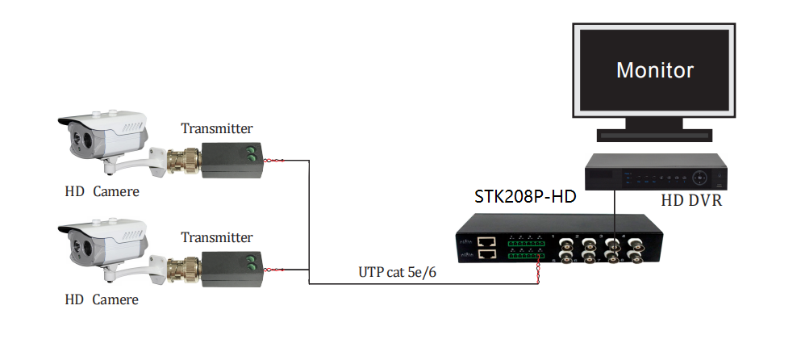
Pictures of this 8 channels Video Balun connect UTP cable Plug and play

